**Project Step 12 - Database Integration**

**Caleb Pleasant**

Database Integration

The project database tables and model classes are connected. Using code, connect to the database and create a controller and a simple view which displays data read from your tables and enables data taken from a simple user interface and storing the new or modified data back to the database.

*Submit:*

1. **screenshot of SSMS showing data stored in tables**

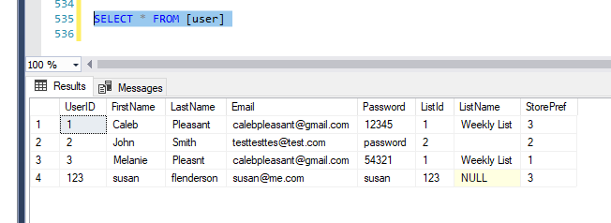

1. **screenshot of application view showing data retrieved from the database and displayed on the page**

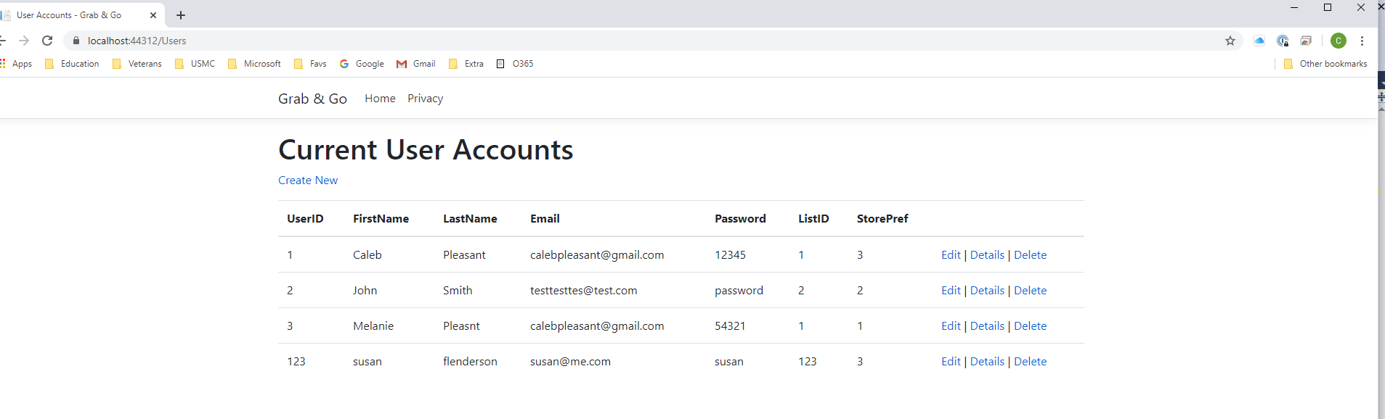

1. **screenshot of your application demonstrating how the data is collected from the application (a form?)**

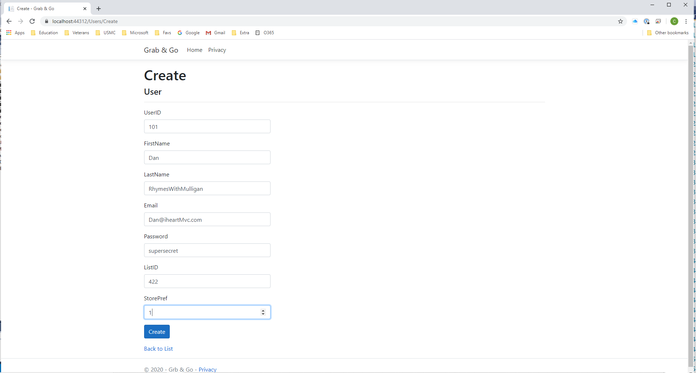

1. **application screenshot of the view (from step 2) showing how the data has changed (following step 3)**

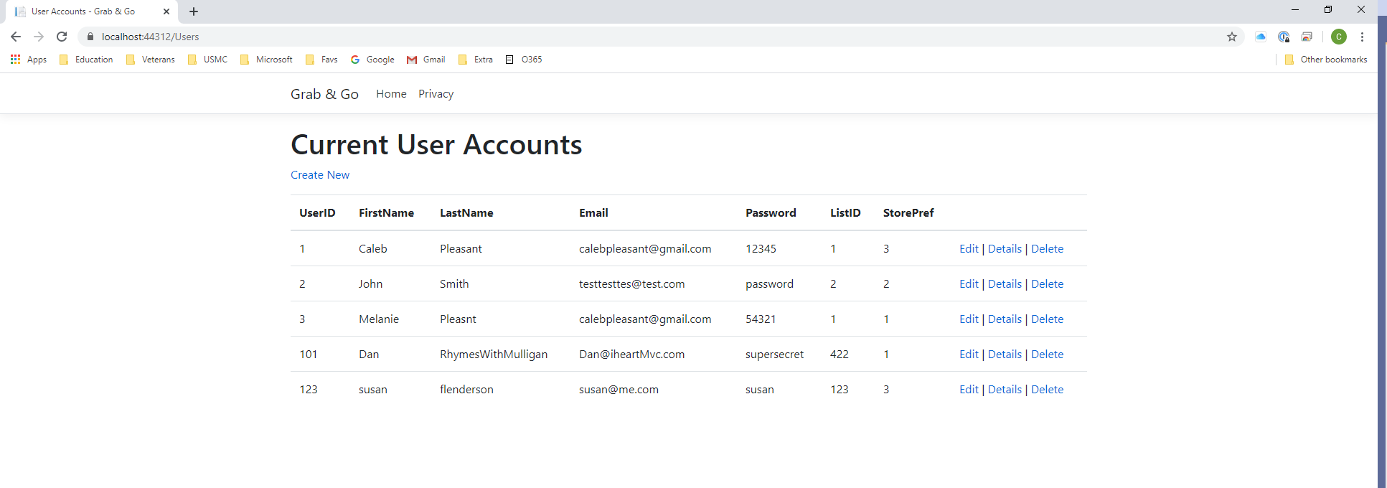

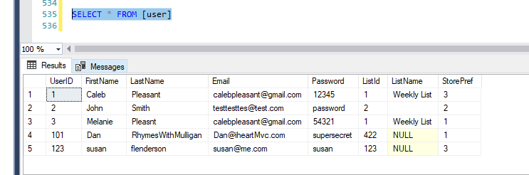

1. **Upload your source code to Github and update your task list showing project progress!**

<https://github.com/cjpleasant88/Grab-Go/tree/master/GrabAndGo>